○○○の研究開発
English form: see next page
Please erase this when you submit your abstract.
出口 祥啓*
*徳島大学大学院理工学研究部, 〒770-8506 徳島市南常三島2丁目1番地
* E-mail: ydeguchi@tokushima-u.ac.jp
1. はじめに
本フォームを使用し，A4 – 1～3枚の概要を作成ください．言語は英語，日本語のどちらかを使用下さい．pdfファイルを提出ください。
2. 実験装置
必要に応じて図表を使用し，説明ください^{[1]}．
3. 計測結果及び考察
・・・・・・・・・・・・・・・・・・・・・・・・・・・・・・・・・・・・・・・・・・・・・・・・・・・・・・・・・・・・・・・・・・・・・・・・・・・・・・・・・・・・・・・・・・・・・・・・・・・・・・・・・・・・・・・．
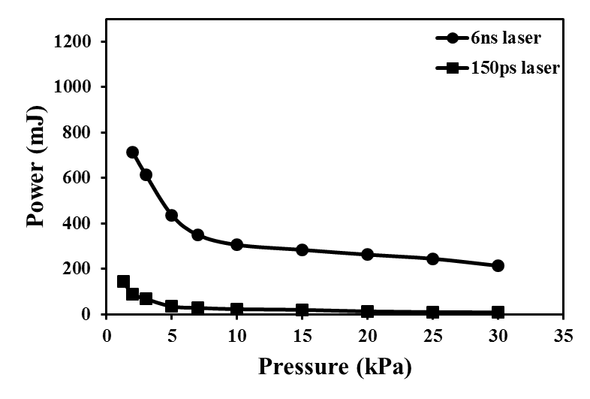
Fig.1 Air plasma generation threshold

4.まとめ
１）・・・．
２）・・・．
参考文献
[1] M. Noda, Y. Deguchi, S. Iwasaki, N. Yoshikawa, “Detection of Carbon Content in a High Temperature and High Pressure Environment Using Laser-Induced Breakdown Spectroscopy”. Spectrochim. Acta, Part B. 2002. 57: 701-709..
[2] ・・・．
Development ... Using Laser Diagnostics
Yoshihiro Deguchi*
Tokushima University, Tokushima 770-8501, Japan
* E-mail: ydeguchi@tokushima-u.ac.jp

1. Introduction
Author(s) will be requested to submit 1 to 3-page summary (pdf file) written in English or Japanese. Use A4 size paper and type your text in 10.5-point Times (New) Roman, single-spaced.
2. Experimental setup
Figures and Tables may be included in the abstract^{[1]}.
3. Results and discussion
................................................................................................................................................................................................................................................................................................
Fig.1 Air plasma generation threshold

4. Conclusion
1) ............
2) ............
References
[1] M. Noda, Y. Deguchi, S. Iwasaki, N. Yoshikawa, “Detection of Carbon Content in a High Temperature and High Pressure Environment Using Laser-Induced Breakdown Spectroscopy”. Spectrochim. Acta, Part B. 2002. 57: 701-709..
[2] ..........

